

**SPORTS MANAGEMENT SYSTEM**

**High Level Design & Low Level Design**

**Document control:**

| **SPORTS MANAGEMENT SYSTEM** | | | | | | | | |
| --- | --- | --- | --- | --- | --- | --- | --- | --- |
| Guided by-BISWA P DAS |  |  | |  |  |  |  |  |
| **Date** | **Version** | **Author** | **Brief Description of Changes** | | | | **Approver Signature** | |
| 20-10-2022 | 1.0 | Group 1:Preetha paulin, Kalaivani c,Renuka devi,Sirisha cheerla,Naga Maheeswari vantakula |  | | | |  | |
|  |  |  |  | | | |  | |
|  |  |  |  | | | |  | |

**Index**

1.Introduction 5

1.1 Intended audience 5

1.2 Project purpose 5

1.3 Key project objective 5

1.4 Project scope 6

2.DesignOverview 6

2.1 Design objective 12

2.2Design Alternative 12

2.3 User interface paradigms 12

2.4 Validations 12

3. Detailed system design 13

3.1 Flowchart of main application 13

3.2 Flowchart of maintain database() 14

3.3 Flowchart of main menu 14

3.4 Flowchart of show report() 15

**1. Introduction**

The sports management system is an application that allows the admin to store the details of each and every student who are registered for sports in a systematic order inside the database removing the traditional way of using scorekeeping where every student had to keep their own scores. Now with the introduction of this system it simplifies the process, now every student record is accessible at a single click then the teachers also mark the attendance of the students who are participated in the various sports and generate the results of the students who won in that specific sport. Then finally list out the sports details with the winner details.

**1.1 Intended Audience:**

The target audience set for this project can be identified as admin and teacher. Where the admin can automate the entire process of handling the sports which includes maintaining records of the students and their scores.

**1.2 Project Purpose:**

The sports management system is a project that helps us understand the basic concepts of functions, file handling, and data structure. The sports management system objective is to provide which manages the activity of many sports at a time. The admin consumes less amount of time when compared to manual paper work through the automated system. The system will take care of all the servicing activity in a quick manner.

**1.3 Key Project Objectives:**

1. Add the sports name and number of students registered for Sports

2. Add the Sports   type as Indoor or Outdoor

3. Add the Teachers and   allocate them to particular Sports Event

4. Add/Edit/Delete/view the details

5. Update the attendance and the winners list of each sports

6. List out the sports details of the first placed in each sport

7. View the sports list and  their results

8. List out the sport pending for the year

9. List out the event completed sports teacher

**1.4 Project scope :**

This project aims to create the development of sports management application, which takes the event and player information from admin such as Sport-ID, Sport-Name, No of students registered, month in which it is held and sports-teacher assigned adds it to the sports-database and the sports-teacher can conduct that event and update the results and returns the Winning data of the players as to display the top three winners and list of sports conducted and their results and ports pending for the year.

**2. Design Overview: -**

## **Sports management system comprises of the following modules in maintain sports database:**

| Name of the Module | Add sports details |
| --- | --- |
| Handled by |  |
| Description | The admin add the sports details in the database. |

| Name of the Module | Delete sports details |
| --- | --- |
| Handled by |  |
| Description | The admin delete the sports details in the database |

## 

| Name of the Module | Edit sports details |
| --- | --- |
| Handled by |  |
| Description | The admin edit the sports details in the database. |

## 

| Name of the Module | view sports details |
| --- | --- |
| Handled by |  |
| Description | The admin can view the sports details in the database. |

## 

| Name of the Module | Maximum registered sports |
| --- | --- |
| Handled by |  |
| Description | The admin can view the maximum sports which registered by the students |

## 

## **Sports management system comprises of the following modules in teachers database:**

| Name of the Module | Add teachers details |
| --- | --- |
| Handled by |  |
| Description | The admin add the teachers details in the database. |

## 

| Name of the Module | Delete teachers details |
| --- | --- |
| Handled by |  |
| Description | The admin delete the teachers details in the database |

## 

| Name of the Module | Edit teachers details |
| --- | --- |
| Handled by |  |
| Description | The admin edit the teachers details in the database. |

## 

| Name of the Module | view teachers details |
| --- | --- |
| Handled by |  |
| Description | The admin can view the teachers details in the database. |

## 

| Name of the Module | mark attendance |
| --- | --- |
| Handled by |  |
| Description | The teacher will record the attendance of each student who has signed up for the event. |

| Name of the Module | update conducted sports results |
| --- | --- |
| Handled by |  |
| Description | The teacher can update the list of sports conducted and their results. |

| Name of the Module | View Results(Mark winners of each round) |
| --- | --- |
| Handled by |  |
| Description | After the event, the teacher will update the winners of each round. |

| Name of the Module | View pending results |
| --- | --- |
| Handled by |  |
| Description | The admin can view the list of sports pending for the year. |

**Sports Management system comprises of the following modules in show reports:**

| Name of the Module | Generate Results(based on max win by a student) |
| --- | --- |
| Handled by |  |
| Description | The teacher can view the results of max win by the students |

| Name of the Module | Generate first placed students |
| --- | --- |
| Handled by |  |
| Description | The report will contain the first placed students across various sports. |

| Name of the Module | Generate pending sports reports |
| --- | --- |
| Handled by |  |
| Description | The report contain the pending sports of this year |

## **2.1 Design Objectives:**

Admin updates the student and teacher information in the sports database. A database for teachers is also maintained by the admin. The winner's information will be updated in the teacher's database. A report will include information on top performers as well as a list of all sports that were completed successfully and teachers information.

**2.2 Design Alternative: -**

We have used a list structure to store data i.e.. sports ID, Name, type(indoor and outdoor),no of students who all registered, month held, assigned details and teachers id, sports which they associated.

**2.3 User Interface Paradigms: -**

The admin will upload information about the sports and teachers, teachers will update the winners' records, and the system will generate a report.

**2.4 Validation: -**

A. All entries across the entire application are validated properly.

B. Use the appropriate data-structures for all processes.

C. Dynamic memory should be used through-out.

D. Only binary files should be used for data storage.

E. Ensure that no memory leak is there throughout the application.

F. Ensure minimum data entry for the entire process by providing a list of options.

G. Instead of frequent file I/O carry out all operations in memory and do the reading/writing to and from file only once at the beginning and end.

**3. DETAILED SYSTEM DESIGN:**

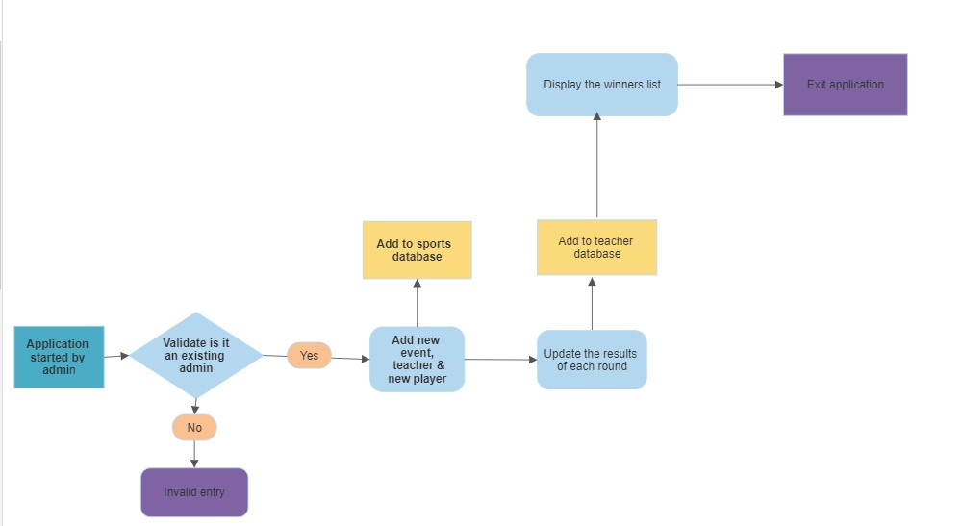

3.1 Flow chart of the main application

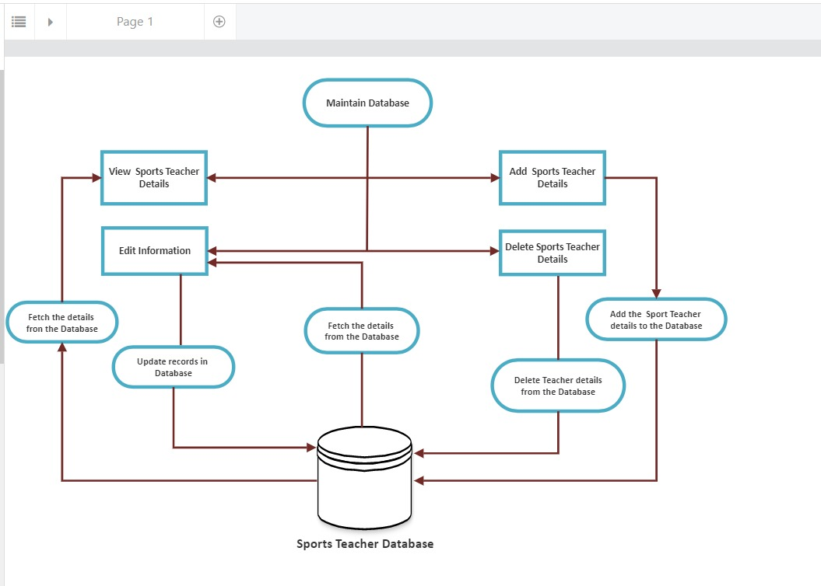

3.2 Flowchart of maintain database

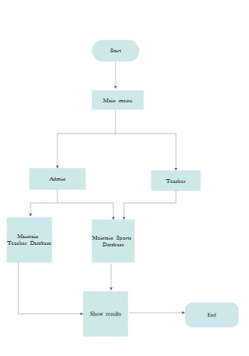

3.3 Flowchart of main menu application

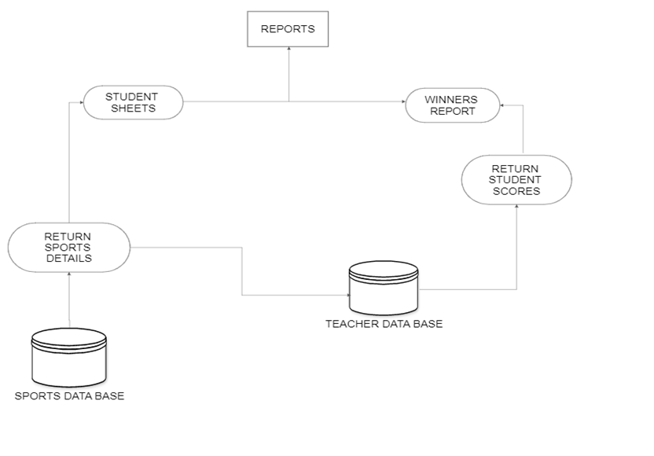

3.3 Flow chart of Reports